Mental Health Department
Exploratory Data Analysis
Name: Ismail Saleh
Contents
Problem Statement: 1
Business Impact: 1
General Dataset Information: 1
Target Features: 1
List of Analysis 2
Analysis #1 – Correlations 2
Analysis #2 - Review Distribution 3
Analysis #3 - Statistics 3
Analysis #4 – Additional Graphs 4
Conclusion 6

Problem Statement:
Many university students suffer from mental health problems. The health department at a certain university aims to locate students experiencing depression or stress to provide suitable care. This includes hiring enough psychiatrists and therapists and purchasing sufficient medications.

Business Impact:
This data could help outline and define the costs needed to treat students while also helping to predict and identify students who might be suffering from mental health issues. This will enable the university to provide care and support to these students in their journey toward better mental health.

General Dataset Information:
File Name: students_mental_health_survey.csv
Description: Mental health evaluation of students
Dataset Details: 7,023 Rows & 20 Columns
Size: 762KB
Source: Kaggle - Dataset Link

Target Features:
The problem statement outlines the essential metrics of finding students who are suffering from mental illness. The key features in question that can be found within the dataset are:
- CGPA
- Quality of sleep
- Diet History
- Mental_illness_total (normalized between 0 and 10)
- Psychiatrist_Need
- Therapist_Need

List of Analysis

Analysis #1 – Correlations
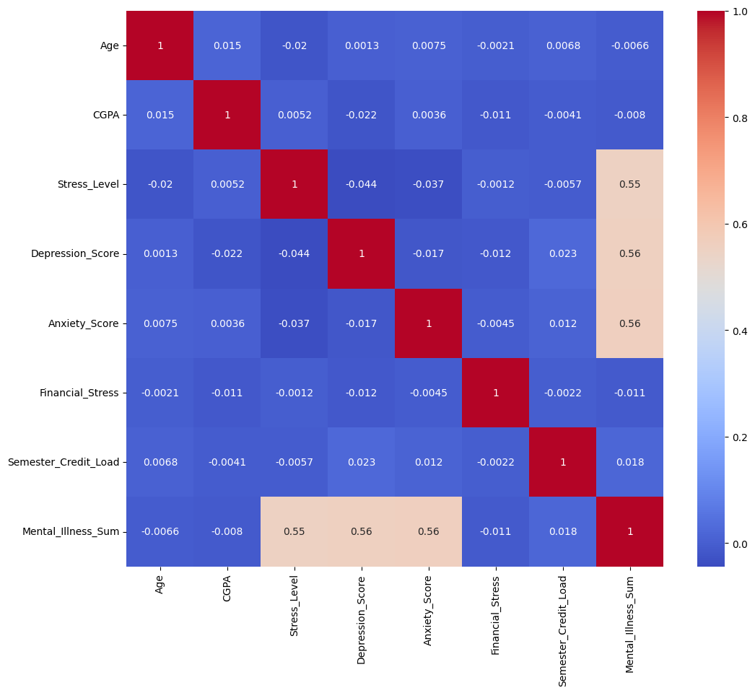
Most attributes had no significant correlation with one another:
This suggests these mental health indicators do not strongly influence each other directly within the dataset.

Analysis #2 - Review Distribution
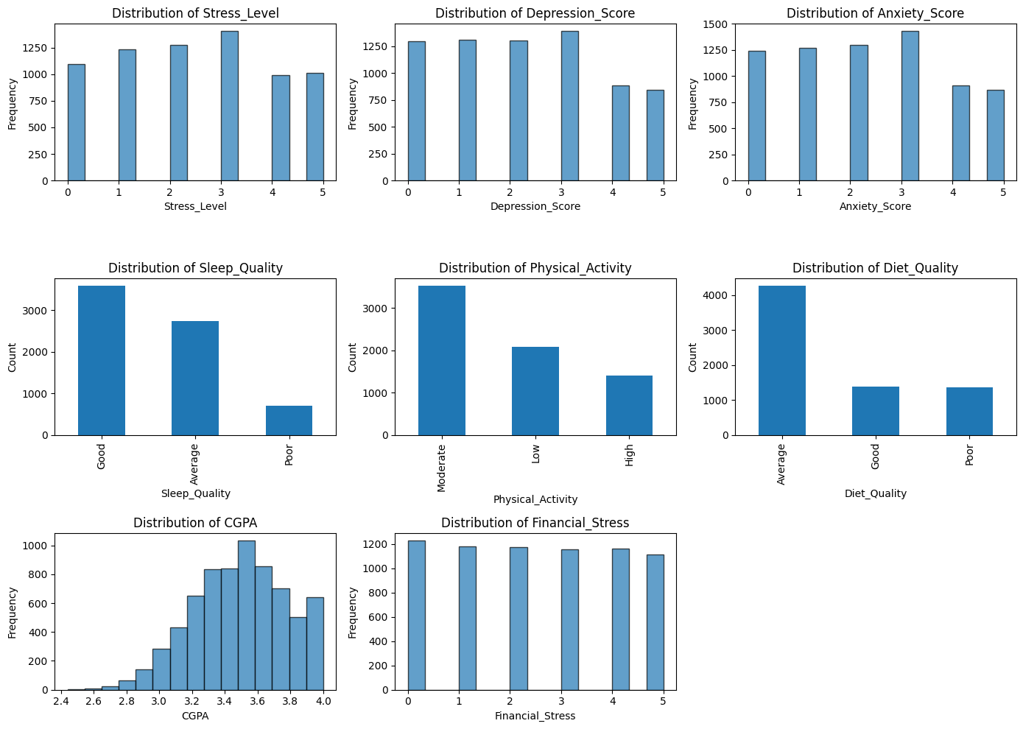
All three target variables (stress_level, depression_score, anxiety_score) had almost identical distribution, thus it was a good choice combining them into one variable (Mental_illness_score).

"Good" Sleep Quality is the most common.
"Moderate" Physical Activity levels dominate.
CGPA follows a bell-shaped distribution, suggesting a central tendency around 3.5.
The distribution is more evenly spread across various stress levels.

Analysis #3 - Statistics
We need to determine how many therapists and psychiatrists the university is going to need according to multiple considerations:
- A therapist can have 30– 40 new patients per month. ^{[1]}
- A psychiatrist can have 100 new patients per month. ^{[2]}
- According to our data, 1101 students need psychiatrists while 1272 need therapists.
- Since the contracts are going to be given annually, each therapist could have 420 (12*35 months in a year * average number of patients a therapist can receive in a month) – patients a year. While a psychiatrist could have 1200 (100 * 12) patients a year.
- In total, a university with a population of 7,000 needs to hire 3 therapists and 1 psychiatrist.
.

Analysis #4 – Additional Graphs
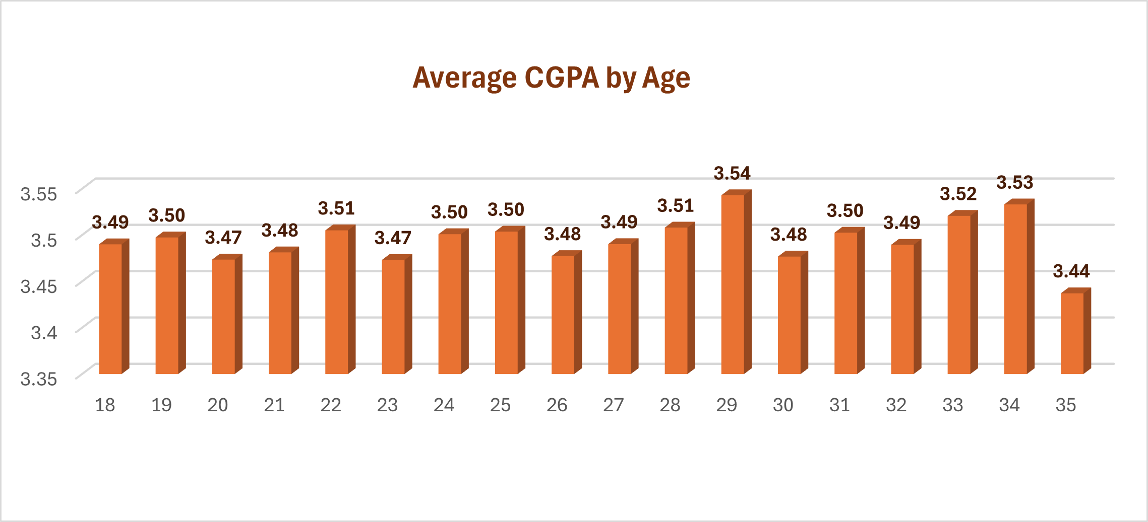
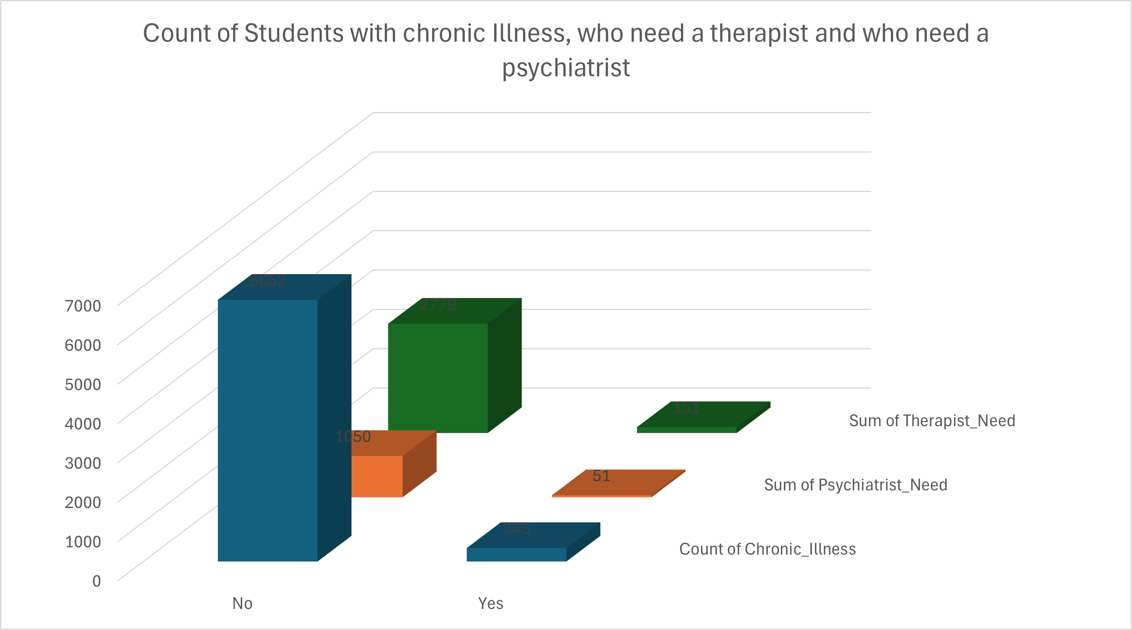

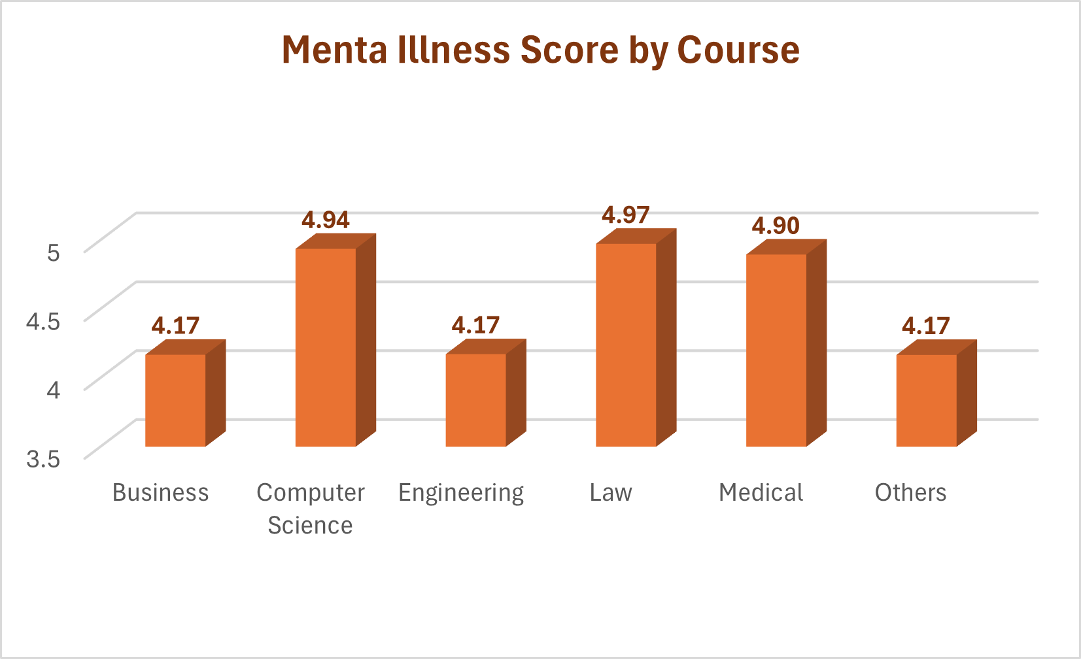
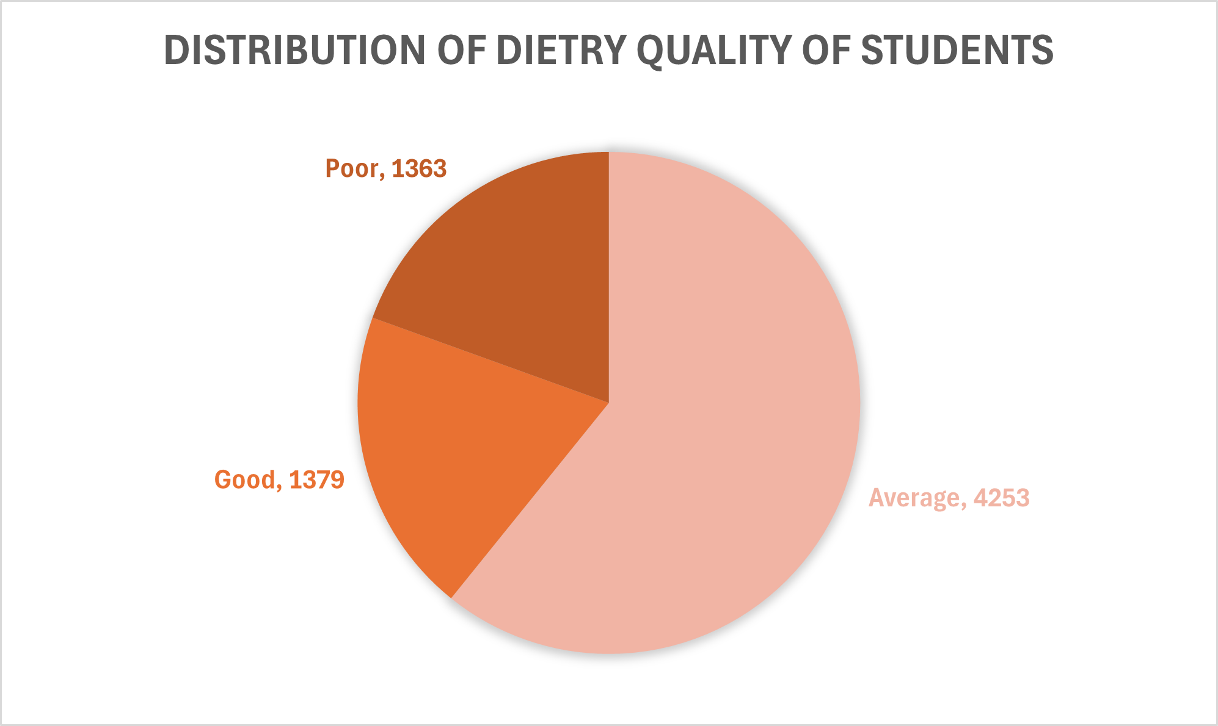

Conclusion

Out of 6996 students, 1101 students need a psychiatrist while 1272 need a therapist. Which makes us need to hire a psychiatrist and 7 therapists, to provide appropriate treatment for their challenges.
The data had shown no strong correlation between only two factors. Either it was sleep quality or CGPA. It looks like students’ emotions are more complex and need a specialist to assess them. No data can make us pinpoint the factors responsible for such complex emotions. Especially if it was self-reported by the students themselves. But, what the data can help us do is to provide support for these students.

